W300D-How to upgrade the firmware?
Product line: ADSL Question category: function configuration

Q: Why we need to upgrade firmware for the router?

A: Sometimes we may need to upgrade the router to another firmware version if the current firmware version can no longer satisfy your requirement. For example, the new firmware will be able to fix some bugs and to achieve better service.

Warning:
1. Upgrade with Ethernet cable, do not upgrade wirelessly, it may cause failure and damage the router.
2. Do not power off the router when upgrading
3. Do not upgrade remotely, please just directly connect your PC and router and perform the upgrade.
4. Please make sure the firmware is correct.
5. We suggest you use Internet Explorer to upgrade.

I. Physical connection:
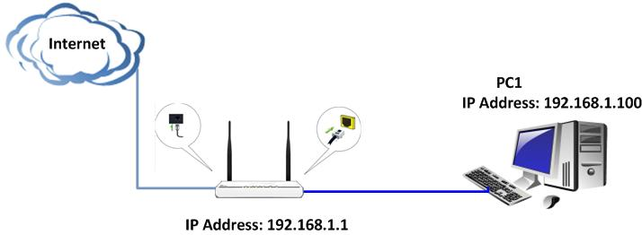
II. Login to the management page of the router:

1. Open a web browser (IE, Firefox, Safari, etc.) and find the address bar, leaving it blank before typing in 192.168.1.1, and then press enter.
(Care: The address bar is in the most top of the web page after opening web browser).
2. Click on Advanced Settings in the following page.
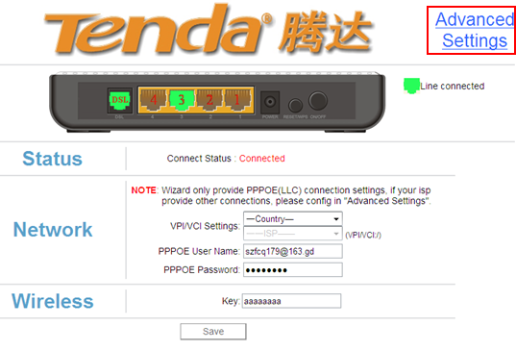
3. You will see the following page.
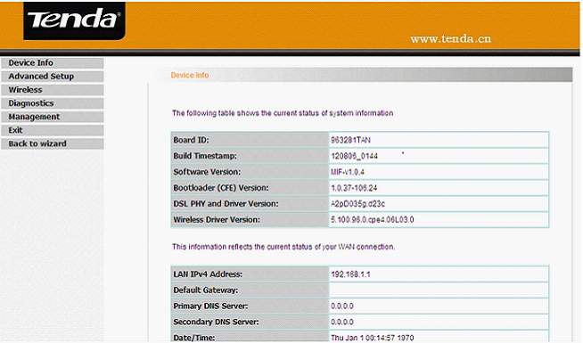

4. Click Management->Update Software on the left side, then click Browse to locate and select the firmware file, then click Update Software to upgrade. The router will reboot after upgrading.
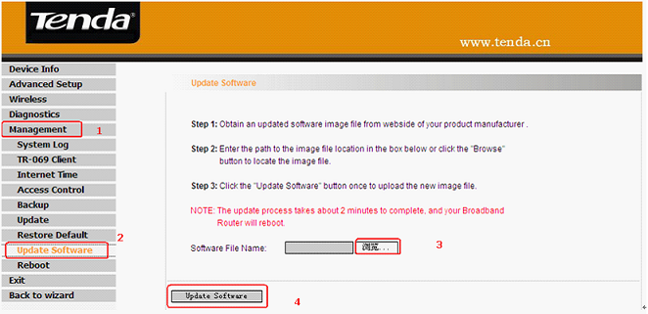

5. After rebooting, please go back to 192.168.1.1 and click on Advanced Settings in the initial page, then go to Management->Restore Default on the left menu to restore the router to factory default. After restoring, you should set up the router again.

